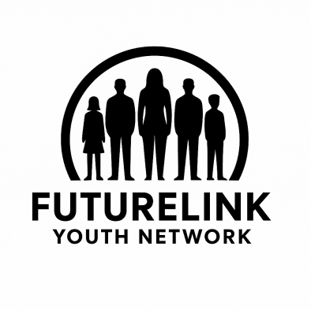

FutureLink Youth Network – Grant Inquiry Capability Statement
FutureLink Youth Network (FYN) is a woman-led, minority-founded nonprofit dedicated to empowering underserved teens of color through financial literacy, workforce development, and leadership training. Based in [Your Region], FYN equips youth with the tools, resources, and confidence to build economic stability and long-term housing security.

Mission Statement
To empower minority teens with financial literacy, workforce skills, and leadership opportunities that foster economic resilience, community strength, and pathways to stable housing.

Vision
A future where all youth of color have equal access to the knowledge, skills, and opportunities they need to thrive, free from systemic barriers to economic and housing stability.

Core Programs
• Financial Literacy 101 – Teaching budgeting, saving, credit, and banking skills.
• Workforce Development – Job readiness, career exploration, and entry-level training opportunities.
• Leadership & Mentorship – Youth-led projects, peer mentorship, and community engagement initiatives.
• Housing Resilience – Integrating financial planning and career pathways that support long-term housing stability.

Organizational Strengths
• Woman-led and minority-founded organization with lived experience at the helm.
• Community-driven and culturally responsive approach to programming.
• Focus on systemic equity and long-term impact for teens of color.
• Strong potential for growth and innovation as a startup nonprofit.

Demographics Served
FYN primarily serves underserved teens of color, ages 13–19, in Fredericksburg, Virginia. Participants are primarily first-generation youth from low-income households disproportionately impacted by systemic inequities and barriers to stable housing.

Budget Snapshot (2025 Proposed)
• Total Proposed Budget: $275,000
• Primary Needs: Program delivery, capacity building, and community partnerships.
• Funding Sought: Support for youth-focused financial literacy, workforce readiness, and housing stability initiatives.

Contact Information
July Silva
Founder and CEO
FutureLink Youth Network
Phone: 703-599-6156
Email: july@futurelinkyouthnetwork.org

