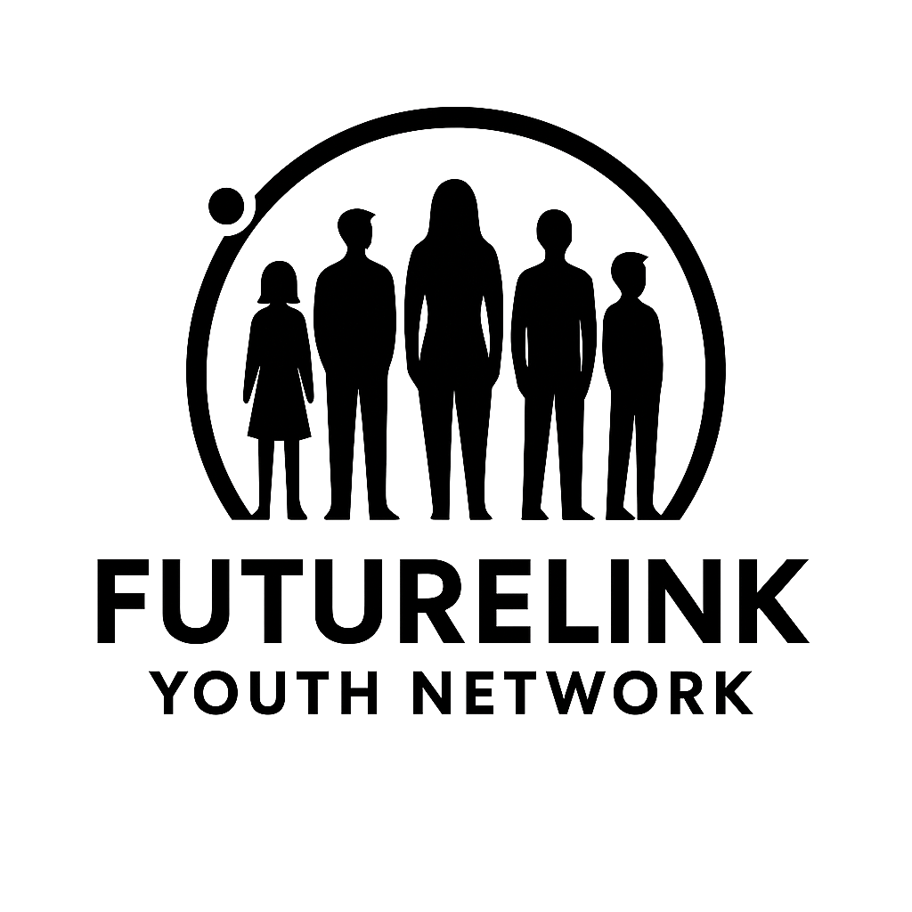

Curriculum Plan
Program Length: 12 Weeks
Audience: High school seniors and young adults (ages 16–24)
Format: Hybrid (In-person + Online components)
Schedule: 15 hours/week (5 hours of instruction + 10 hours of hands-on training or apprenticeships)
Assessment: Weekly skill checks, final project/presentation, employer evaluation for apprentices

Finance & Business Administration
Objective: Equip students with foundational business and financial literacy, bookkeeping skills, and entrepreneurship basics.
Weeks 1–4:
- Financial Literacy 101
- Introduction to Bookkeeping and Excel/Google Sheets
- Understanding Income, Expenses, and Cash Flow
- Entrepreneurial Mindset & Business Planning
Weeks 5–8:
- Managing Invoices and Payments
- Intro to QuickBooks or Wave Accounting
- Customer Service & Communication in Business
- Team Collaboration & Workplace Etiquette
Weeks 9–12:
- Build Your Own Business Plan
- Final Project: Present a Microbusiness Idea
- Mock Interviews & Career Planning
- Apprenticeship with local accounting/business office

Automotive Technology
Objective: Provide foundational training in automotive repair, maintenance, and diagnostics.
Weeks 1–4:
- Auto Safety & Workshop Tools
- Intro to Vehicle Systems
- Oil Change, Tire Rotation, Fluid Checks
- Reading Vehicle Codes
Weeks 5–8:
- Brake Systems & Troubleshooting
- Battery & Electrical Repairs
- Customer Service in Auto Shops
- Field Trip to Partner Auto Shop
Weeks 9–12:
- Real-World Diagnostics
- Resume Writing & Job Applications
- Final Test: Repair Simulation
- Paid Apprenticeship or Job Shadowing

Construction & Skilled Trades
Objective: Train students in entry-level skills for carpentry, plumbing, and electrical work.
Weeks 1–4:
- OSHA Safety Training
- Hand & Power Tools Basics
- Intro to Carpentry
- Framing and Drywall
Weeks 5–8:
- Plumbing Basics
- Wiring and Electrical Work
- Measuring and Blueprint Reading
- Mini Build Project
Weeks 9–12:
- Job Site Simulations
- Contractor Site Visits
- Final Practical Exam
- Internship Placement

Culinary Arts & Hospitality
Objective: Prepare students for roles in food service, hospitality, and culinary entrepreneurship.
Weeks 1–4:
- Kitchen Safety & Food Sanitation
- Knife Skills & Cooking Methods
- Nutrition & Menu Planning
- Hospitality Basics
Weeks 5–8:
- Table Service & Etiquette
- Food Truck & Event Planning
- Guest Chef Sessions
- Restaurant Field Trip
Weeks 9–12:
- Pop-Up Café Project
- Resume & Food Handler Certification
- Mock Interviews with Restaurants
- Apprenticeship/Internship

Sewing & Fashion Design
Objective: Teach students to design, sew, and manage a garment-based business.
Weeks 1–4:
- Sewing Machine Basics
- Fabric Types & Stitching
- Fashion Sketching
- Garment Construction
Weeks 5–8:
- Alterations & Tailoring
- Pattern Making & Sizing
- Branding & Fashion Marketing
- Supply Chain & Pricing
Weeks 9–12:
- Fashion Line Final Project
- Showcase Event
- Fashion Photography
- Designer Mentorship

Denture Lab Technology
Objective: Train students in the fundamentals of dental prosthetic fabrication and lab safety.
Weeks 1–4:
- Oral Anatomy Overview
- Dental Materials & Lab Safety
- Denture Lab Equipment Intro
- Molding & Casting Techniques
Weeks 5–8:
- Acrylic Denture Base Work
- Waxing & Tooth Setup
- Polishing Techniques
- Record Keeping in Labs
Weeks 9–12:
- Final Denture Project
- Dental Lab Resume Workshop
- Guest Speaker from Lab Industry
- Internship in a Dental Lab

Tax Preparation & Financial Literacy
Objective: Teach students how to prepare basic individual tax returns and understand personal finance.
Weeks 1–4:
- U.S. Tax System Overview
- W-2s, 1099s, and Income Types
- Filing Status & Deductions
- Taxpayer Rights
Weeks 5–8:
- IRS Tools and Tax Software
- Federal and State Filing
- Filing Simulations
- Tax Ethics and Confidentiality
Weeks 9–12:
- Client Intake Practice
- Simulated Tax Return Project
- CPA Guest Workshop
- Community Tax Help Event

Cyber Coding & IT Fundamentals
Objective: Introduce students to computer programming and cybersecurity basics.
Weeks 1–4:
- Computers & Internet 101
- Intro to Python Programming
- Web Design: HTML & CSS
- Cybersecurity Basics
Weeks 5–8:
- Intermediate Python (Loops, Lists, Functions)
- Cyber Threats & Prevention
- Group Coding Labs
- Hacking Simulation (Ethical)
Weeks 9–12:
- Capstone Website or App
- Cybersecurity Pathways Panel
- Resume & LinkedIn for Tech Careers
- Internship with Tech Partner

Additional Curriculum Elements (All Tracks)
- Weekly Career Readiness Workshops (Resumes, Interview Skills, LinkedIn)
- “Entrepreneurship Fridays” (cross-track business building sessions)
- Guest Speakers from Industry Partners
- Personal Coaching Sessions (Bi-weekly)

